PROJECT SYNOPSIS

##### on

**CultureCrafter**

###### for

**Babu Banarasi Das University**

**towards partial fulfillment of the requirement**

**for the award of degree of**

###### Master of Computer Applications

**from**

# Babu Banarasi Das University

**Lucknow**



**Academic Session 2023 - 24**

### School of Computer Applications

| **I Floor, H-Block, BBDU, BBD City, Faizabad Road, Lucknow (U. P.) INDIA 226028**  **PHONE: HEAD:** 0522-3911127, 3911321 **Dept. Adm. & Exam Cell:** 0522-3911326 **Dept. T&P Cell:** 0522-3911128; **E-Mail:** head.sca@gmail.com |
| --- |
| **www.bbdu.ac.in** |

PROJECT SYNOPSIS

##### on

**CultureCrafter**

###### for

**Babu Banarasi Das University**

**towards partial fulfillment of the requirement**

**for the award of degree of**

###### Master of Computer Applications

**from**

# Babu Banarasi Das University

**Lucknow**



**Developed and Submitted by**

1220212114

VARSHA GUPTA

**Academic Session 2023 - 24**

### School of Computer Applications

| **I Floor, H-Block, BBDU, BBD City, Faizabad Road, Lucknow (U. P.) INDIA 226028**  **PHONE: HEAD:** 0522-3911127, 3911321 **Dept. Adm. & Exam Cell:** 0522-3911326 **Dept. T&P Cell:** 0522-3911128; **E-Mail:** head.sca@gmail.com |
| --- |
| **www.bbdu.ac.in** |

**School of Computer Applications**

**BBBU**

**TRAINING DETAILS PROFORMA**



PROJECT SYNOPS

**TUSSEL**

**Introduction:**

The aim of competitive programming is to write source code of computer programs which are able to solve given problems. A vast majority of problems appearing in programming contests are mathematical or logical in nature. Typical such tasks belong to one of the following categories: combinatorics, number theory, graph theory, algorithmic game theory, computational geometry, string analysis and data structures. Problems related to constraint programming and artificial intelligence are also popular in certain competitions.

Today in the World of Technology-A Digital World. Coding competition are vastly conduct in many places such as Schools, Colleges, Companies, Institutions, etc., for many purposes such as hiring, hack quest, hackathon, etc.

**Introduction:**

Starting college is like entering a bustling city without a map. Imagine being a new student, surrounded by diverse clubs, each in a unique neighbourhood, and feeling a bit lost. You want to join in, but where do you start? This is the challenge faced by many freshmen—missing out on the vibrant college culture and struggling to connect with clubs and experienced seniors.

It's like standing at the entrance of a fantastic theme park but not knowing which rides to try. The current system lacks a friendly guide to help newcomers navigate this exciting, but overwhelming, terrain. The solution is to create a warm and accessible platform, like College-Club, a virtual friend that not only introduces students to the array of clubs but also connects them with seasoned seniors.

College-Club aims to provide a centralized platform for students to discover, join, and actively participate in various clubs based on their interests. The College Club not only facilitates the exploration of existing clubs but also empowers students to initiate and manage their own clubs, fostering a culture of creativity and inclusivity.

**Scope & Objective:**

**Club Discovery**: Students can easily navigate through an extensive database of clubs, categorized by interests, activities, and fields of study. This feature ensures that every student can find a club that aligns with their passions and aspirations.

**Club Creation**: Recognizing the diversity of interests among students, the system allows them to propose and establish new clubs.

**Comprehensive Club Information**: The system provides detailed information about each club, including its mission, activities, meeting schedules, and contact details. This ensures that students can make informed decisions about the clubs they wish to be a part of.

**Meeting Schedules**: Students can access up-to-date information on club meetings, events, and activities. This feature enables better coordination and participation, fostering a sense of community and collaboration among club members.

**Admin Availability**: The system provides visibility into club administrators' availability, making it easier for students to connect with the leaders of their chosen clubs. This enhances communication and collaboration between club members and administrators.

**Resources (Hardware & Software) to be used:**

1. **Hardware Requirements**

* **Client Side**

| Processor | Dual Core or above |
| --- | --- |
| RAM | 8 GB |
| Disk space | 256 GB (SSD) |
| Monitor | Desktop/laptop/ tab/ mobile |
| Network | Internet Connection |
| Other | Keybourd /Mouse |

* **Developer Side**

| Processor | Quad Core or above (2 GHz or more) |
| --- | --- |
| RAM | 8 GB or above |
| Disk space | 500 GB (SSD) |
| Monitor | Desktop/Laptop |
| Network | Internet Connection |

1. **Software Requirements**

* **Client Side**
* Web Browser (Google Chrome, Firefox, Microsoft Edge, Apple Safari or above)
* **Developer Side**
* Web Browser (Google Chrome, Firefox, Microsoft Edge, Apple Safari)
* Node JS 20 or above
* Vs code
* Frontend Framework – React 18
* Backend Framework – Express JS
* Database - MongoDB

**Project Schedule Plan:**

The objective of Software Planning is to provide a framework that enables the manager to make reasonable estimates of resources, cost, and schedule. These estimates are made within a limited time frame at the beginning of a software project and should be updated regularly as the project progresses. In addition, estimates should attempt to define best case and worst-case scenario so that project outcomes can be bounded.

**Gantt Chart:**

A Gantt chart is popular type of chart that illustrates a project schedule. Gantt Chart illustrates the start and finish dates of the terminal elements and summary elements of a project. Terminal element and summary comprise the work breakdown structure of the project.

| **Task** | **5Feb-24Feb** | **25Feb-6Mar** | **7Mar-16Mar** | **17Mar-16Apr** | **17Apr-21Apr** | **22Apr-7May** |
| --- | --- | --- | --- | --- | --- | --- |
| **Develop project proposal** | 20 days |  |  |  |  |  |
| **Analysis** |  | 10 days |  |  |  |  |
| **Designing** |  |  | 10 days |  |  |  |
| **Coding** |  |  |  | 33days |  |  |
| **Unit Testing** |  |  |  |  | 5 days |  |
| **Implementation** |  |  |  |  |  | 15 days |

Gantt Chart

**Project Team:**

**Instructor :** Mohammad Mubassir

**Mentor :** Mr. Sarfaraz Alam

**Project Team Members :** Varsha Gupta,

Rohit Kumar Sharma

**Process Description:**

**1. Club Organizer:**

The Club Organizer is responsible for creating and managing clubs within the system. This includes initiating new clubs, setting up club details, and overseeing club-related activities.

**2. Browsing System:**

The Browsing System enables students to explore and discover various clubs available in the college. It provides a user-friendly interface for searching and filtering clubs based on interests, activities, or fields of study.

**3. Club Members Manager:**

This component handles the management of club members, allowing organizers to add or remove members, track attendance, and maintain an updated roster of individuals participating in each club.

**4. AI Moderation System:**

The AI Moderation System ensures that content shared within clubs aligns with community guidelines. It uses artificial intelligence algorithms to monitor and moderate discussions, posts, and interactions to maintain a positive and respectful environment.

**5. Messaging System:**

Facilitating communication among club members, the Messaging System allows for real-time chat, discussion forums, and the sharing of information within the club. It enhances collaboration and engagement among members.

**6. Scheduling System:**

The Scheduling System manages and displays club meeting schedules and events. It allows organizers to set up recurring meetings, announce special events, and helps members stay informed about upcoming activities.

**7. Notification System:**

The Notification System sends alerts and updates to club members, organizers, and administrators. It ensures timely communication regarding new club activities, upcoming meetings, or important announcements.

**8. Club Theme Manager:**

The Club Theme Manager allows organizers to customize the visual appearance of their club pages. It includes options for selecting themes, colors, and branding elements to create a unique identity for each club.

**9. UI Animations Handler:**

Responsible for enhancing user experience, the UI Animations Handler adds dynamic and interactive elements to the user interface. It includes animations that improve navigation, engagement, and overall aesthetics of the system.

**10. Student Feedback System:**

The Student Feedback System gathers feedback from club members about their experiences. It provides a platform for members to express their opinions, suggestions, and concerns, contributing to continuous improvement and optimization of the club management system.

**Use Case Diagram**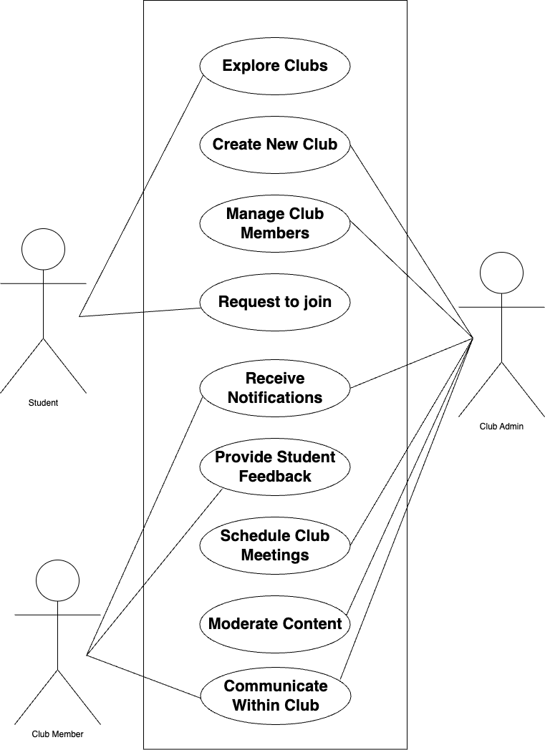

**Contribution of the student in the project:**

1. **Varsha Gupta:**  Club Organizer, Club Members Manager, AI Moderation System, Club Theme Manager, UI Animations Handler

1. **Rohit Kumar Sharma:** Browsing System, Messaging System, Scheduling System, Notification System, Student Feedback System

**Conclusion:**

The College Club is a helpful tool for students. It makes it easy for them to find, join, and run clubs at college. The system is designed to be user-friendly, allowing students to explore different clubs and even start their own. It's not just about joining existing clubs; students can suggest new ones, making the system inclusive and engaging.

The system uses artificial intelligence to keep discussions respectful and positive. It also has features like messaging and scheduling to help clubs coordinate their activities. By being open to user feedback and allowing customization, the system aims to create a lively and personalized space for students. In simple terms, the College Club is a friendly and practical way to make the most out of college life, bringing students together and making extracurricular activities more enjoyable.